**Rayat Shikshan Sanstha’s**

**Radhabai Kale Mahila Mahavidyalaya,**

**Ahmednagar**



**A**

**Project Report On**

**“*Cosmatic Product”***

***Project by***

***Miss. Kadus Sakshi Vinay***

***In project fulfillments of the requirement for the B.B.A. (C.A)***

***Semester-IV Course***

***Under guidance:***

***Prof. Mrs. Dethe n.s.***

***Submitted to***

***Savitribai Phule Pune University, Pune.***

***2023-2024***

Date: - / / .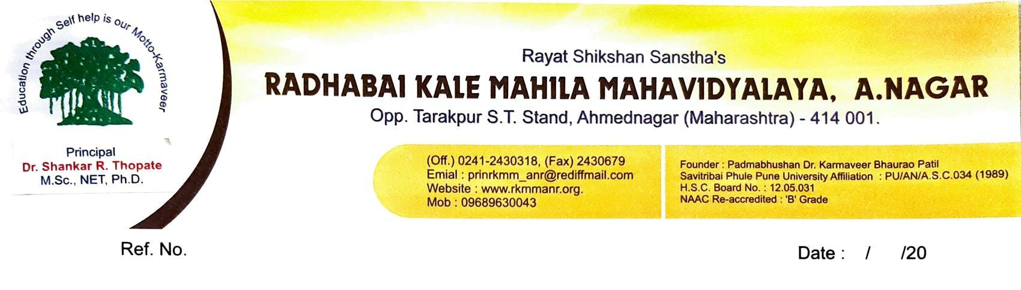

**CERTIFICATE**

*This is to certify that Miss.* ***Kadus sakshi vinay*** *student of our college has been completed S.Y.B.B.A. (Computer Application) semester* ***IV*** *project successfully on* ***"Cosmatic Product"*** *during the academic year 2023-24.*

*Internal HOD*

*External Principal*

**INDEX**

|  |  |  |
| --- | --- | --- |
| ***Srno*** | ***Title*** | ***Pages*** |
| ***1*** | ***Project title page with project name, college name,college logo, guide name etc.*** |  |
| ***2*** | ***Certificate*** |  |
| ***3*** | ***Project overview*** |  |
|  | ***3.1. Introduction*** |  |
|  | ***3.2. Scope and Objective*** |  |
|  | ***3.3. Existing System & Proposed System*** |  |
| ***4*** | ***Project Design*** |  |
|  | ***4.1. E-R Diagram*** |  |
|  | ***4.2 Use Case Diagram*** |  |
|  | ***4.3 Sequence Diagram*** |  |
|  | ***4.4. Activity Diagram*** |  |
|  | ***4.5 DFD (if Required)*** |  |
|  | ***4.6 System Architecture (if Any)*** |  |
| ***5*** | ***Snapshots*** |  |
| ***6*** | ***Project Implementation (if implemented)*** |  |
|  | ***6.1 project implementation technology*** |  |
| ***7*** | ***Testing*** |  |
|  | ***7.1 level of testing*** |  |
|  | ***7.2 Test Cases*** |  |
| ***8*** | ***Advantages and limitation of project*** |  |
| ***9*** | ***Conclusion*** |  |
| ***10*** | ***bibliography*** |  |

**\*Project Profile\***

|  |  |
| --- | --- |
| ***Project Title:*** | *Cosmatic product* |
| ***Front End Tools:*** | *VisualCode* |
| ***Back End Tools:*** | *PHP, PhpMyAdmin* |
| ***Documentation Tool:*** | *Microsoft Word 2010* |
| ***Operating System:*** | *Windows 7,10, 11* |
| ***Submitted By:*** | *Miss.Kadus sakshi vinay* |
| ***Submitted To:*** | *R.K.M.M.College,Ahmednagar* |
| ***Guided By:*** | *Mrs. Dethe.n.s* |

***3.Project overview***

**Introduction**

*A Cosmetic store is a web based application where users can view various cosmetic products along with their description. The project provides user with a flexible & attractive GUI & shows them a list of products & carry out all the shopping activities online.*

*This project is developed for users to have a brief look at the cosmetics products without actually visiting the store. The website displays different kinds of products of different brands so that user can easily get their expected cosmetic products.*

**Scope**

***Scope and Objective***

* *Provides the good user interface to ease of use and it also provides the security to the database.*
* *This system can view the details of any record.*
* *Locate any cosmetic product information wanted by the user.*
* *Reduced clerical work as most of the work done by computer.*
* *Provide greater speed & reduced time consumptions.*

***SCOPE OF WORK***

* *Manage online shopping easily.*
* *Secure registration & profile management facilitiesfor customer.*
* *Easy & Quick access to particular product & services.*
* *This System is easy in handle & user friendly.*
* *Time required for accessing any detail will be very less.*
* *User can view details of the parts without going anywhere.*
* *It is Convenient for users as this system provides accurate cost & description of the system.*

**Infrastructure**

*The infrastructure of a Cosmatic Product includes physical, technological, and operational elements that collectively support its daily operations and customer service. Here's a breakdown of the key components of a typical Cosmatic product’s infrastructure:*

***Physical Space****: SUGAR Cosmetics is a powerful, confident, inspired, and bold makeup brand that refuses to conform to boring stereotypes. The brand or the cosmetics line is manufactured in state-of-the-art facilities across Germany, Italy, India, USA, and Korea.*

***Display and Shelving****: Shelf life is usually 36 month from the date of manufacturing.*

***FACT FINDING TECHNIQUES***

*Fact-finding techniques are essential for gathering information and understanding the requirements, challenges, and opportunities within a Cosmatic shop business. Here are some fact-finding techniques specifically tailored for a product shop:*

***Observation****: Spend time observing the daily operations of the cosmatic shop, both in the front-of-house (customer interactions, product displays) and back-of-house (floral design, inventory management). Note any bottlenecks, inefficiencies, or areas where workflow could be improved*.

***Surveys and Questionnaires****:* *Distribute surveys or questionnaires to customers to gather feedback on their experiences with the cosmatic shop. Ask about their preferences regarding products, pricing, customer service, and overall satisfaction. Use the responses to identify areas for enhancement.*

***Sales and Inventory Analysis****: Analyze sales data and inventory records to gain insights into product popularity, seasonal trends, and purchasing patterns. Identify best-selling products, and opportunities for cross-selling or upselling.*

**Competitive Analysis**: *Research competitors in the local area and beyond to understand their offerings, pricing strategies, marketing tactics, and customer base. Identify areas where the flower shop can differentiate itself or capitalize on untapped market opportunities.*

***SWOT Analysis (Strengths, Weaknesses, Opportunities, Threats)****:* *Conduct a SWOT analysis to assess the cosmatic sho's internal strengths and weaknesses, as well as external opportunities and threats. This can help identify areas for improvement and potential areas of growth.*

***Customer Feedback and Reviews****:* *Monitor online reviews, social media comments, and customer feedback channels to gauge customer sentiment and identify areas for improvement. Pay attention to recurring themes or issues mentioned by customers.*

***Consultation with Industry Experts****:* *Seek advice and insights from industry experts, floriculture associations, or consultants specializing in retail floral businesses. They can provide valuable guidance based on their experience and knowledge of industry trends.*

**DFD Diagram 1st Level and Context Level**

**Services choose service**

**user**

**admin**

Show request Cosmetic shop

**level DFD:**

Admin Dashboard

Database

**level DFD:**

user Dashboard

Database

***DATA DICTIONARY***

*Data Flow Diagrams themselves not describe all details about data flows. For investigation one more tool is used to support DFD which is called as data dictionary. Data dictionary provides additional information about system.DD is called as the catalog.*

*DD is an analysis tool that primarily records the information content of data. It of stores definitions of all data mentioned in DFD& in a process specification.*

***1. Login Table:-***

|  |  |  |  |
| --- | --- | --- | --- |
| ***Field name*** | ***Data type*** | ***Description*** | ***Size*** |
| *Login_ID* | *Text* | *Login ID* | *15* |
| *Password* | *Text* | *password* | *15* |

*2.****RegistrationTable:-***

|  |  |  |
| --- | --- | --- |
| ***Field name*** | ***Data type*** | ***Description*** |
| *regis_ID* | *Number* | *Register ID* |
| *First_name* | *Text* | *First name* |
| *Last_name* | *Text* | *Last name* |
| *Address* | *Text* | *Address* |
| *Email_id* | *Text* | *Email_id* |
| *Password* | *Text* | *Password* |
| *cPassword* | *Text* | *cPassword* |

***3****.****Contact Us Table:-***

|  |  |  |
| --- | --- | --- |
| ***Field name*** | ***Data type*** | ***Description*** |
| *id* | *Number* | *id* |
| *Name* | *Text* | *Name* |
| *Email* | *Number* | *Email* |
| *M_no* | *Text* | *M_no* |
| *msg* | *Text* | *msg* |

***4)Add Product***

|  |  |  |
| --- | --- | --- |
| *id* | *Number* | *id* |
| *name* | *text* | *name* |
| *price* | *Number* | *price* |
| *description* | *text* | *description* |

***5.Bill Detail Table:-***

|  |  |  |
| --- | --- | --- |
| ***Field name*** | ***Data type*** | ***Description*** |
| *Booking_id* | *Number* | *Booking id* |
| *P_name* | *Text* | *P_name* |
| *price* | *Text* | *price* |
| *qty* | *Text* | *qty* |
| *Final_amt* | *number* | *Final_amt* |
| *Email* | *Number* | *Email* |

|  |  |  |
| --- | --- | --- |
| *City* | *Text* | *City* |
| *state* | *Text* | *state* |
| *pincode* | *Number* | *pincode* |

***6.Payment Table:-***

|  |  |  |
| --- | --- | --- |
| ***Field name*** | ***Text*** | ***Description*** |
| *ID* | *Number* | *ID* |
| *name* | *Text* | *Name_card* |
| *number* | *Text* | *Number_card* |
| *month* | *Text* | *month* |
| *year* | *Text* | *year* |

***1).Home Page:***

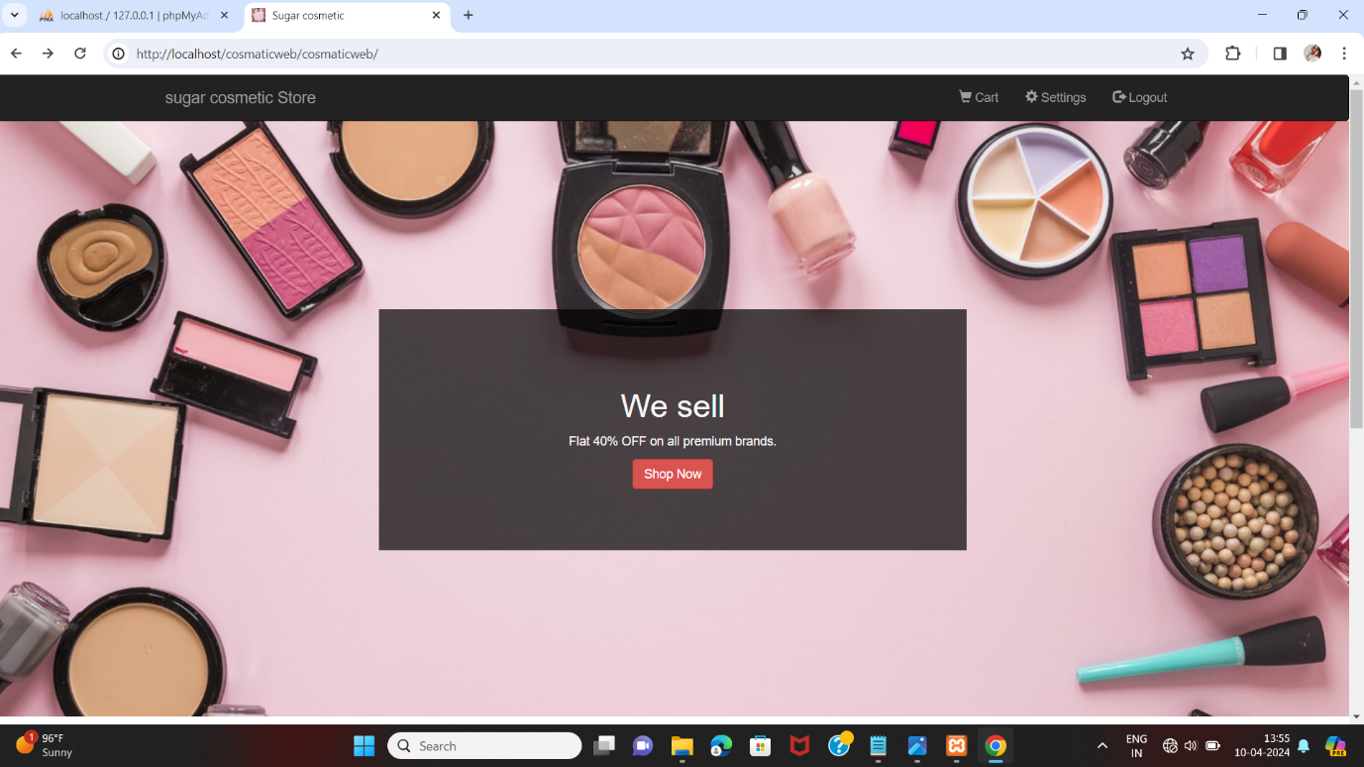

***2.)Categories***

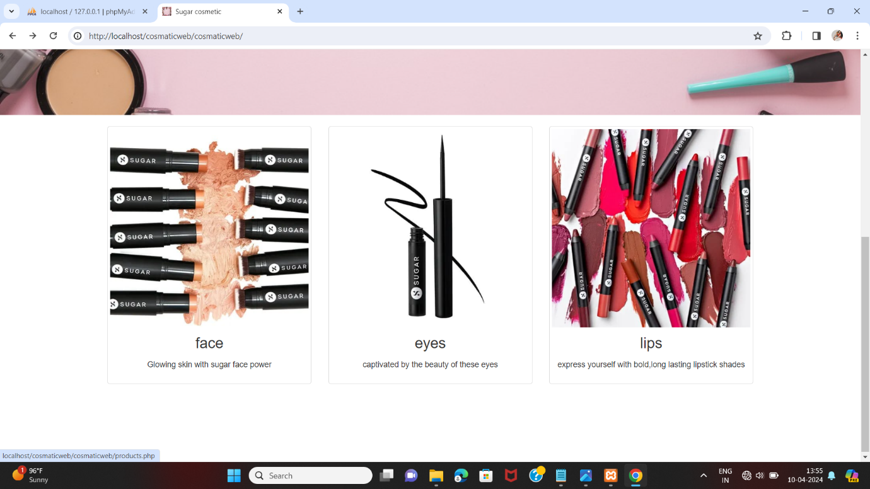

***3)login form:***

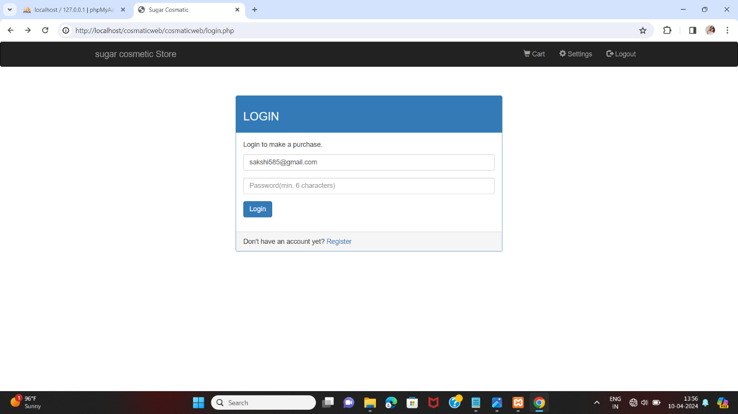

***4)Contact Us***

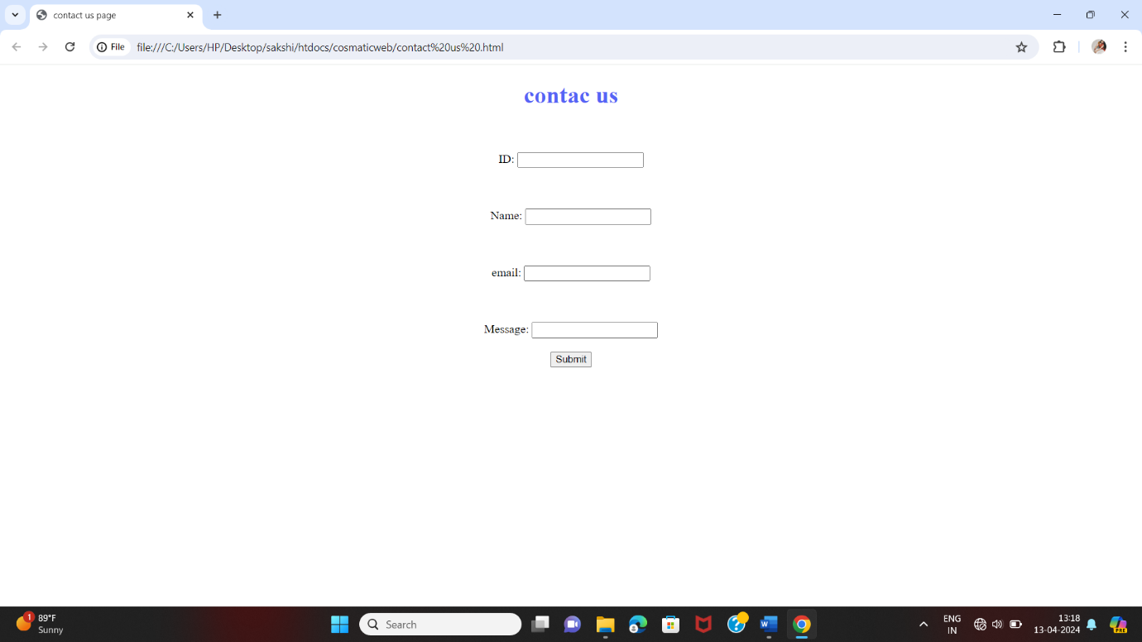

***5)About us:***

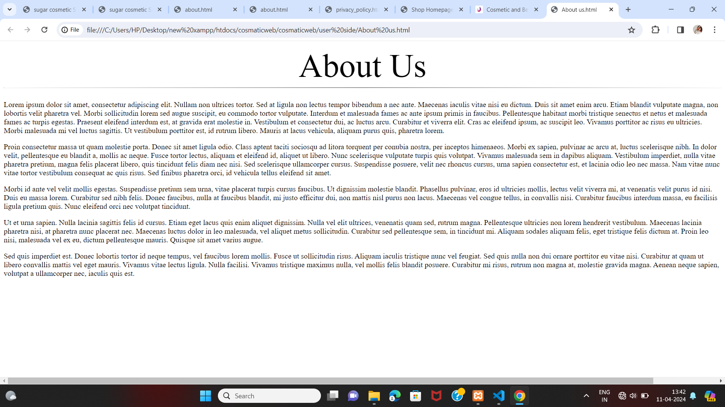

***6)Sign up*** 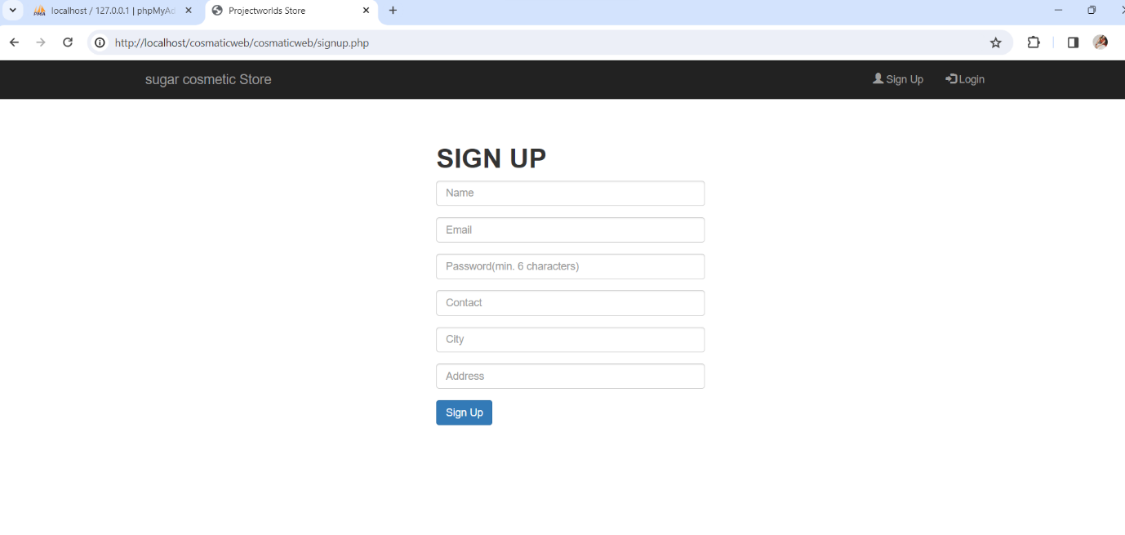

***7)Product’s:***

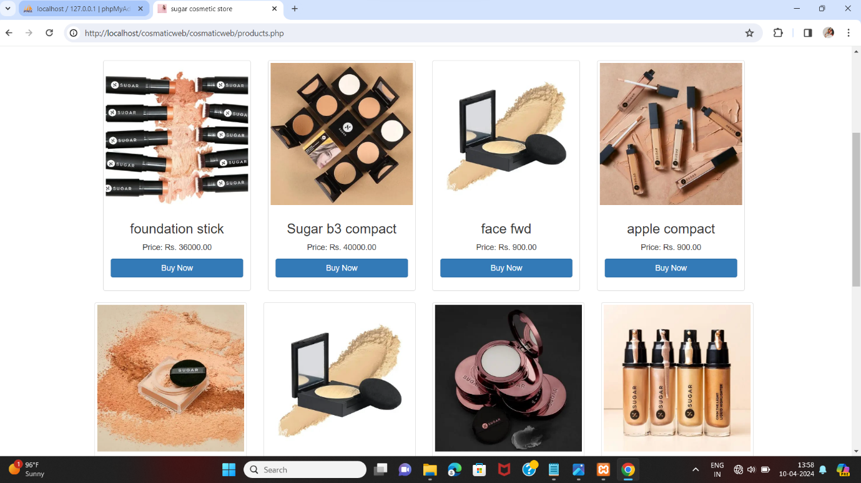

***8)order form:***

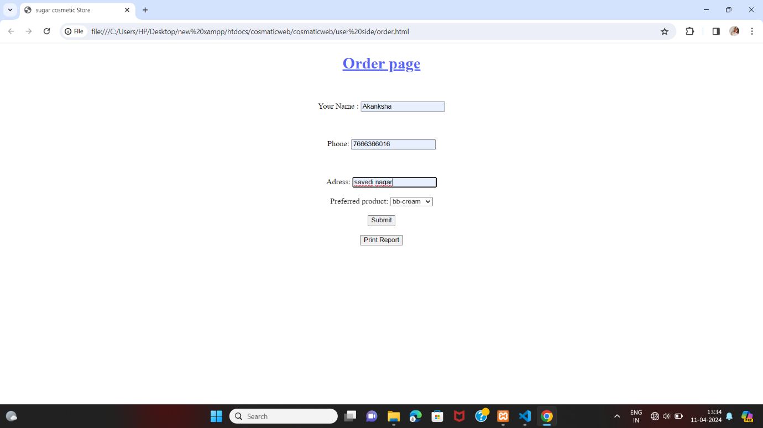

***9)Order page:***

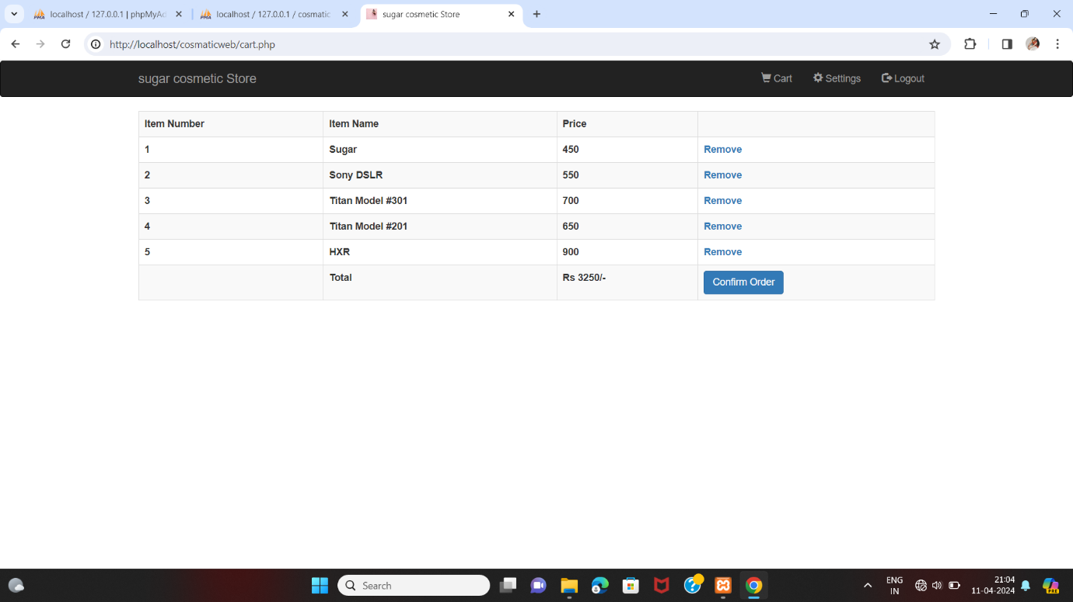

***10)confirm order:***

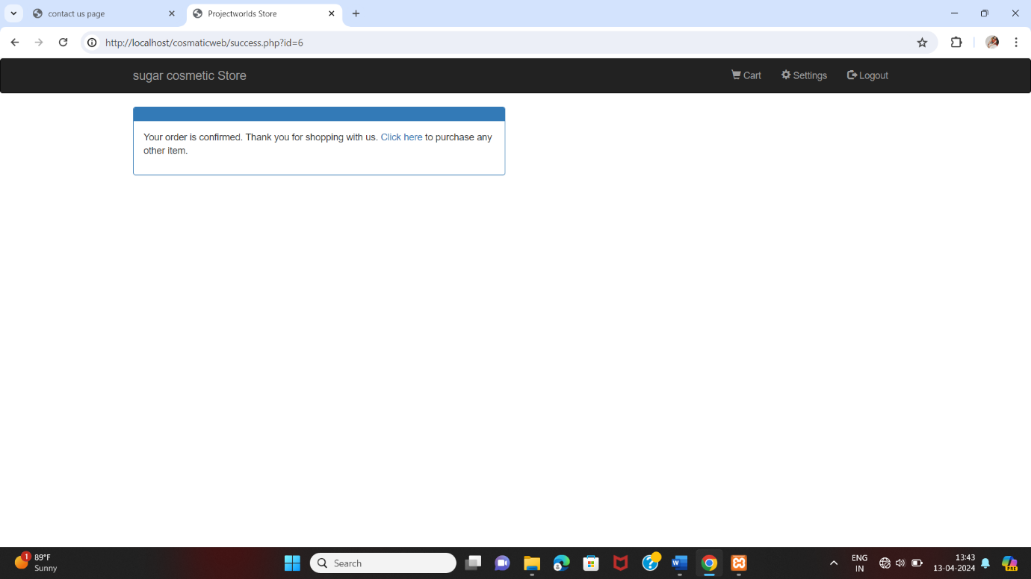

***11)Payment form:***

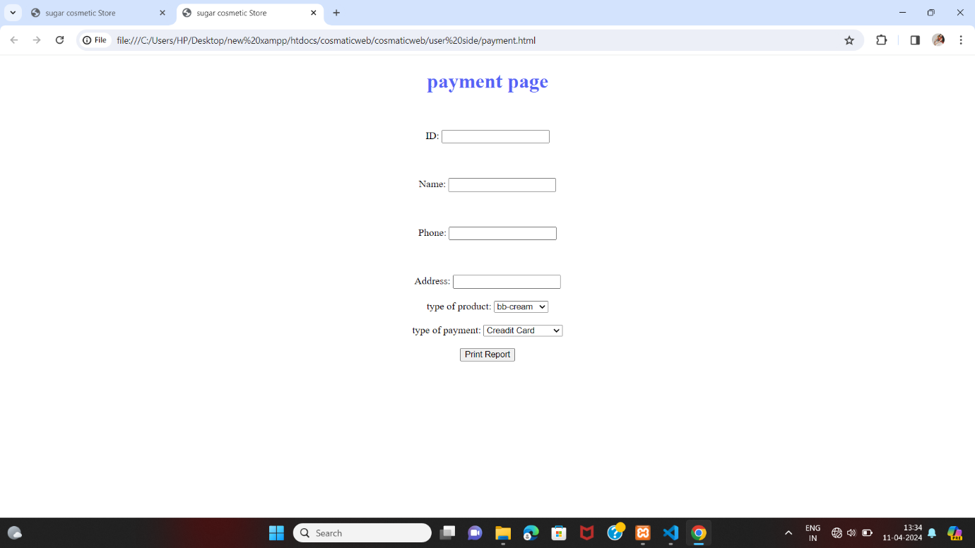

***12)logout :***

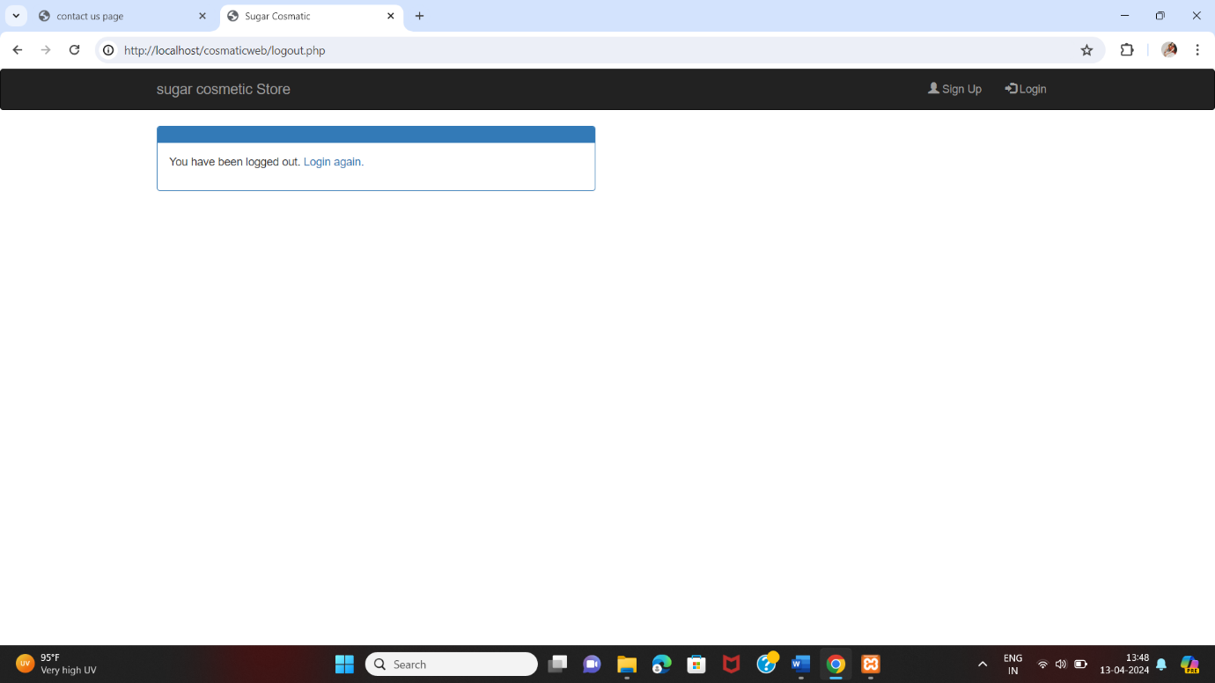

***Project Implementation (if implemented)***

***1 project implementation technology***

***Hardware specification: -***

***Client side: -***

|  |  |
| --- | --- |
| **RAM** | 8GB |
| **Hard disk** | 512 |
| **processor** | 3.30GHz |

**Server side:**

|  |  |
| --- | --- |
| **Web server** | Google chrome |
| **Server-Side Language** | PHP |
| **Database server** | MYSQL |
| **Operating system** | Windows11 |

**Testing**

**1 level of testing**

*The testing process focus on the logical intervals of the software enduring that all the statement has been tested and on functional interval is conducting tests to uncover error and ensure that define input will produce actual result that agree with the require result. Program level testing, module level testing integrating and carried out.*

*There are two mains so testing they are*

1. *White Box Testing*
2. *Black Box Testing*

*1****.White Box Testing:***

* *It is also called as STRUCTURAL TESTING or GLASS BOX TESTING*
* *Testers use the knowledge of internal logic of the system.*
* *Mostly verification techniques are used.*
* *It does not ensure that the user requirement has been met.*
* *The test may not mimic the real-world situation.*
* *Cost is very high since expert tester are required.*
* *Example: - Feasibility review, designer review, code inspection and code walk feasibility review, designer review, code inspection code walk through.*

***2. Black Box Testing:***

* *It is also called as FUCTIONAL TESTING. These tests are conducted at interface.*
* *Tester does not have information about the internal functionality of the system.*
* *Mostly validation technique is used.*
* *They have potential of not detecting the logical errors.*
* *The possibility that efforts are duplicate is high*
* *Example: unit testing, integration testing, system testing, and acceptance testing.*

***Advantages and limitation of project***

***1 Advantages :***

* *With online platforms, you can shop for your favorite beauty products anytime and anywhere.*
* *All you need is a device with internet access.*
* *Just a few clicks and you will have the product in your cart.*
* *You can choose an easy payment option like cash on delivery, if you do not want to pay using your credit or debit card.*

***2 limitation:***

***1. Relatively large amounts paid in advance:***

*This is one matter with roots in the psychological background of most of us and it takes time to override it. The modes operands of small scale trade for millennia is to immediately get what you paid for.*

***2. Security of payment and shipping:***

*The security of your payment is a serious issue and you have to make sure it is properly dealt with by checking the security policy of the cosmetic product merchant. In many cases though, the merchant is as exposed to fraud, as the customer and even more, since he have to ship an expensive product before payment is cleared.*

***3. Impossibility to examine and try on:***

*one of the limitations of online shopping for cosmetics. Since you can't physically examine or try on the products, it can be challenging to assess things like the color, texture, or suitability for your skin type.. However this is promptly addressed with the implementation of proper return policy. A good return policy is one which provides a 30 day money back guarantee or possibly longer.*

***4. Impatience and Conversation:***

*These personal qualities of some custmores, are big disadvantages to the online cosmetic shopping and unfortunately there is no viable strategy to deal with them. My only advice to the customer in doubt is: Give it a chance. It may turn the hassle and hesitation into a pleasurable and existing experience.*

***Conclusion***

* *Online shopping is a convenient way to purchase a variety of products.*
* *However, some items are superior when purchased in a physical store.*
* *As a result, everyone expects online retailers to advance their technology in the future, resulting in a more direct and realistic shopping experience.*

***10.bibliography***

***REFERENCE BOOKS:***

* ***PHP & MySQL Web development by Luke Welling.***
* ***Javascript for modern Web-development By Alok Ranjan.***
* ***SYBBA(CA) PHP Book By Nirali Publications.***
* ***Advance CSS By Mr. Upadhyay.***

***WEBSITES:***

* [***https://www.geeksforgeeks.org***](https://www.geeksforgeeks.org)
* [***https://www.tutorialrepublic.com***](https://www.tutorialrepublic.com)
* [***https://www.youtube.com***](https://www.youtube.com)
* [***http://go.microsoft.com/fwlink/?linkid=140813***](http://go.microsoft.com/fwlink/?linkid=140813)